**Tabla 1. Varianza explicada y la varianza acumulada por cada componente**

|  |  |  |
| --- | --- | --- |
| **Componente** | **Varianza Explicada** | **Varianza Acumulada** |
| PC1 | 0.5164 | 0.5164 |
| PC2 | 0.06465 | 0.58105 |
| PC3 | 0.05264 | 0.63369 |
| PC4 | 0.04203 | 0.67572 |
| PC5 | 0.03689 | 0.71261 |
| PC6 | 0.03469 | 0.7473 |
| PC7 | 0.0304 | 0.7777 |
| PC8 | 0.02635 | 0.80405 |
| PC9 | 0.02381 | 0.82786 |
| PC10 | 0.01961 | 0.84747 |
| PC11 | 0.01811 | 0.86558 |
| PC12 | 0.0174 | 0.88298 |
| PC13 | 0.01547 | 0.89845 |
| PC14 | 0.01271 | 0.91116 |
| PC15 | 0.0121 | 0.92326 |
| PC16 | 0.00925 | 0.93251 |
| PC17 | 0.00898 | 0.94149 |
| PC18 | 0.00762 | 0.94911 |
| PC19 | 0.00692 | 0.95603 |
| PC20 | 0.00639 | 0.96242 |
| PC21 | 0.00574 | 0.96816 |
| PC22 | 0.00421 | 0.97237 |
| PC23 | 0.00383 | 0.9762 |
| PC24 | 0.00337 | 0.97957 |
| PC25 | 0.00299 | 0.98256 |
| PC26 | 0.00245 | 0.98501 |
| PC27 | 0.0022 | 0.98721 |
| PC28 | 0.00195 | 0.98916 |
| PC29 | 0.0017 | 0.99086 |
| PC30 | 0.00141 | 0.99227 |
| PC31 | 0.0012 | 0.99347 |
| PC32 | 0.00105 | 0.99452 |
| PC33 | 0.00093 | 0.99545 |
| PC34 | 0.00084 | 0.99629 |
| PC35 | 0.00066 | 0.99695 |
| PC36 | 0.00063 | 0.99758 |
| PC37 | 0.00054 | 0.99812 |
| PC38 | 0.00042 | 0.99854 |
| PC39 | 0.00036 | 0.9989 |
| PC40 | 0.00032 | 0.99922 |
| PC41 | 0.00022 | 0.99944 |
| PC42 | 0.0002 | 0.99964 |
| PC43 | 0.00012 | 0.99976 |
| PC44 | 0.00008 | 0.99984 |
| PC45 | 0.00006 | 0.9999 |
| PC46 | 0.00004 | 0.99994 |
| PC47 | 0 | 0.99994 |

Fuente: Elaboración propia

**Tabla descriptiva 2. Media y desviación estándar de la varianza acumulada y la varianza explicada**

|  |  |  |  |  |  |
| --- | --- | --- | --- | --- | --- |
| Componente  (media) | Componente  (SD) | Varianza explicada (media) | Varianza explicada (SD) | Varianza acumulada  (media) | Varianza acumulada  (SD) |
| 24 | 14 | 0.021 | 0.075 | 0.92 | 0.12 |

Fuente: Elaboración propia; SD: Desviación estándar

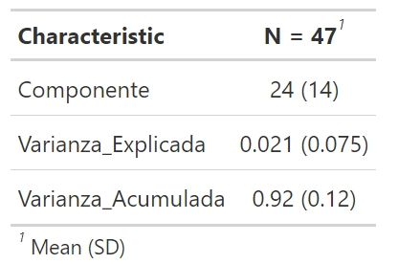

Fuente: Elaboración propia; N: Número de componentes